Pyramid-Based Composite Solids Formed by Addition

Definition
# Source: AI Source: Provided by: [Data Path: Persons Table -> ID Column: 1, Name_En Column: Motasem Essam] -> From: [ChatGPT] on [7/25/2026]
Pyramid-Based Composite Solids are three-dimensional geometric solids formed by joining two or more pyramids, or by combining one or more pyramids with other geometric solids.
The component pyramids may differ in their base shapes, base dimensions, heights, orientations, and positions. They can be joined through their bases, lateral faces, or other matching contact regions to create a larger composite solid.
Examples include:
- Two square pyramids joined base-to-base.
- A square pyramid placed on top of a cube.
- A rectangular pyramid joined to a rectangular prism.
- Multiple pyramids arranged around a common central region.
- A pyramid combined with a cylinder or another solid.

Simple Definition
# Source: AI Source: Provided by: [Data Path: Persons Table -> ID Column: 1, Name_En Column: Motasem Essam] -> From: [ChatGPT] on [7/25/2026]
A pyramid-based composite solid is a 3D shape made by joining pyramids with other pyramids or geometric solids.

Geometric Representation
# Source: AI Source: Provided by: [Data Path: Persons Table -> ID Column: 1, Name_En Column: Motasem Essam] -> From: [ChatGPT] on [7/25/2026]
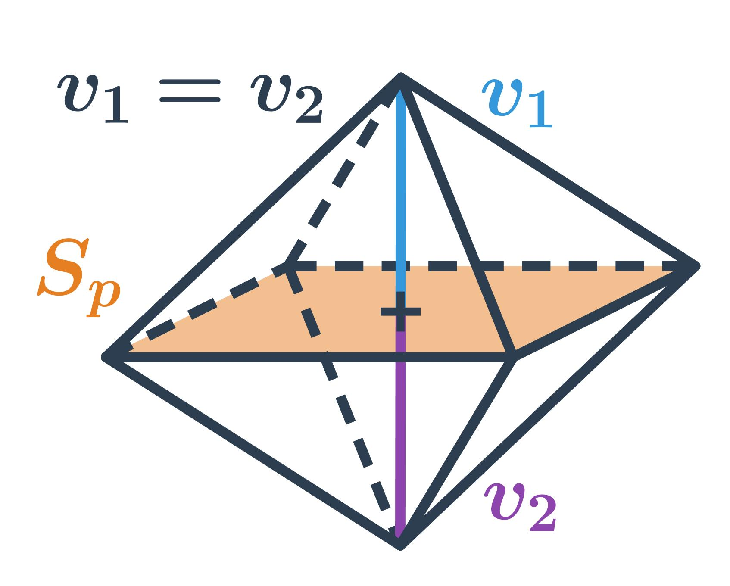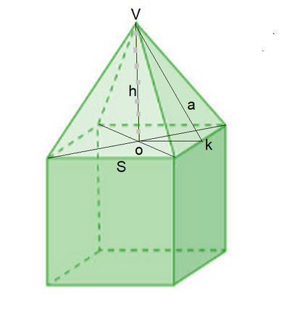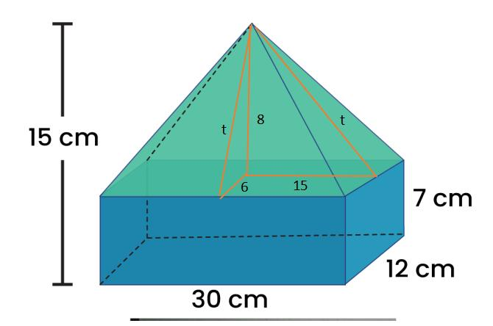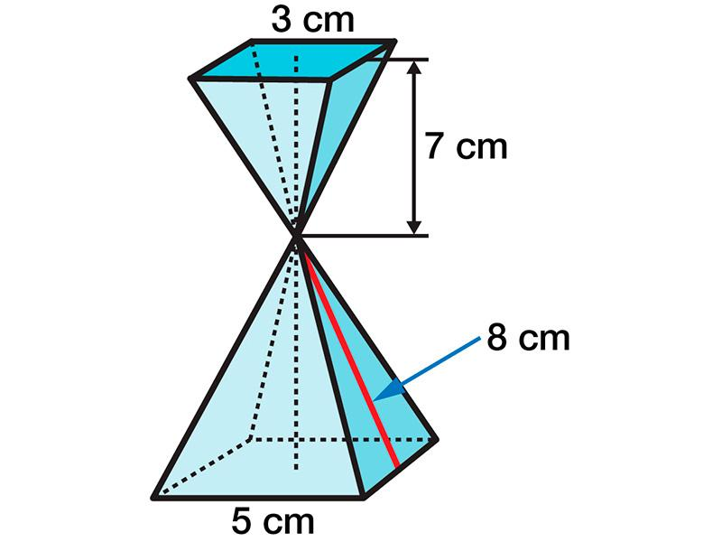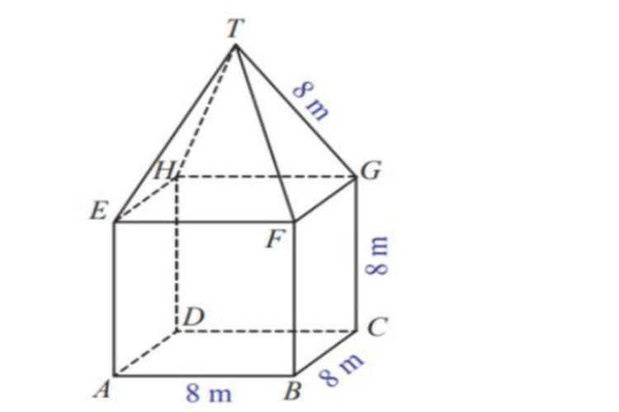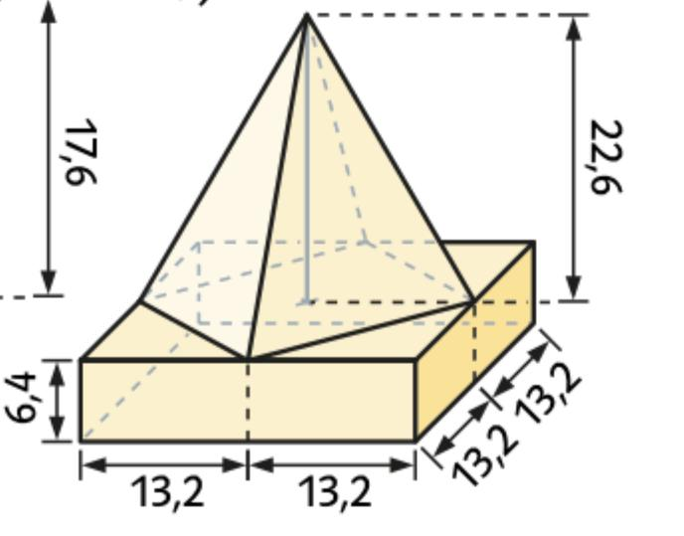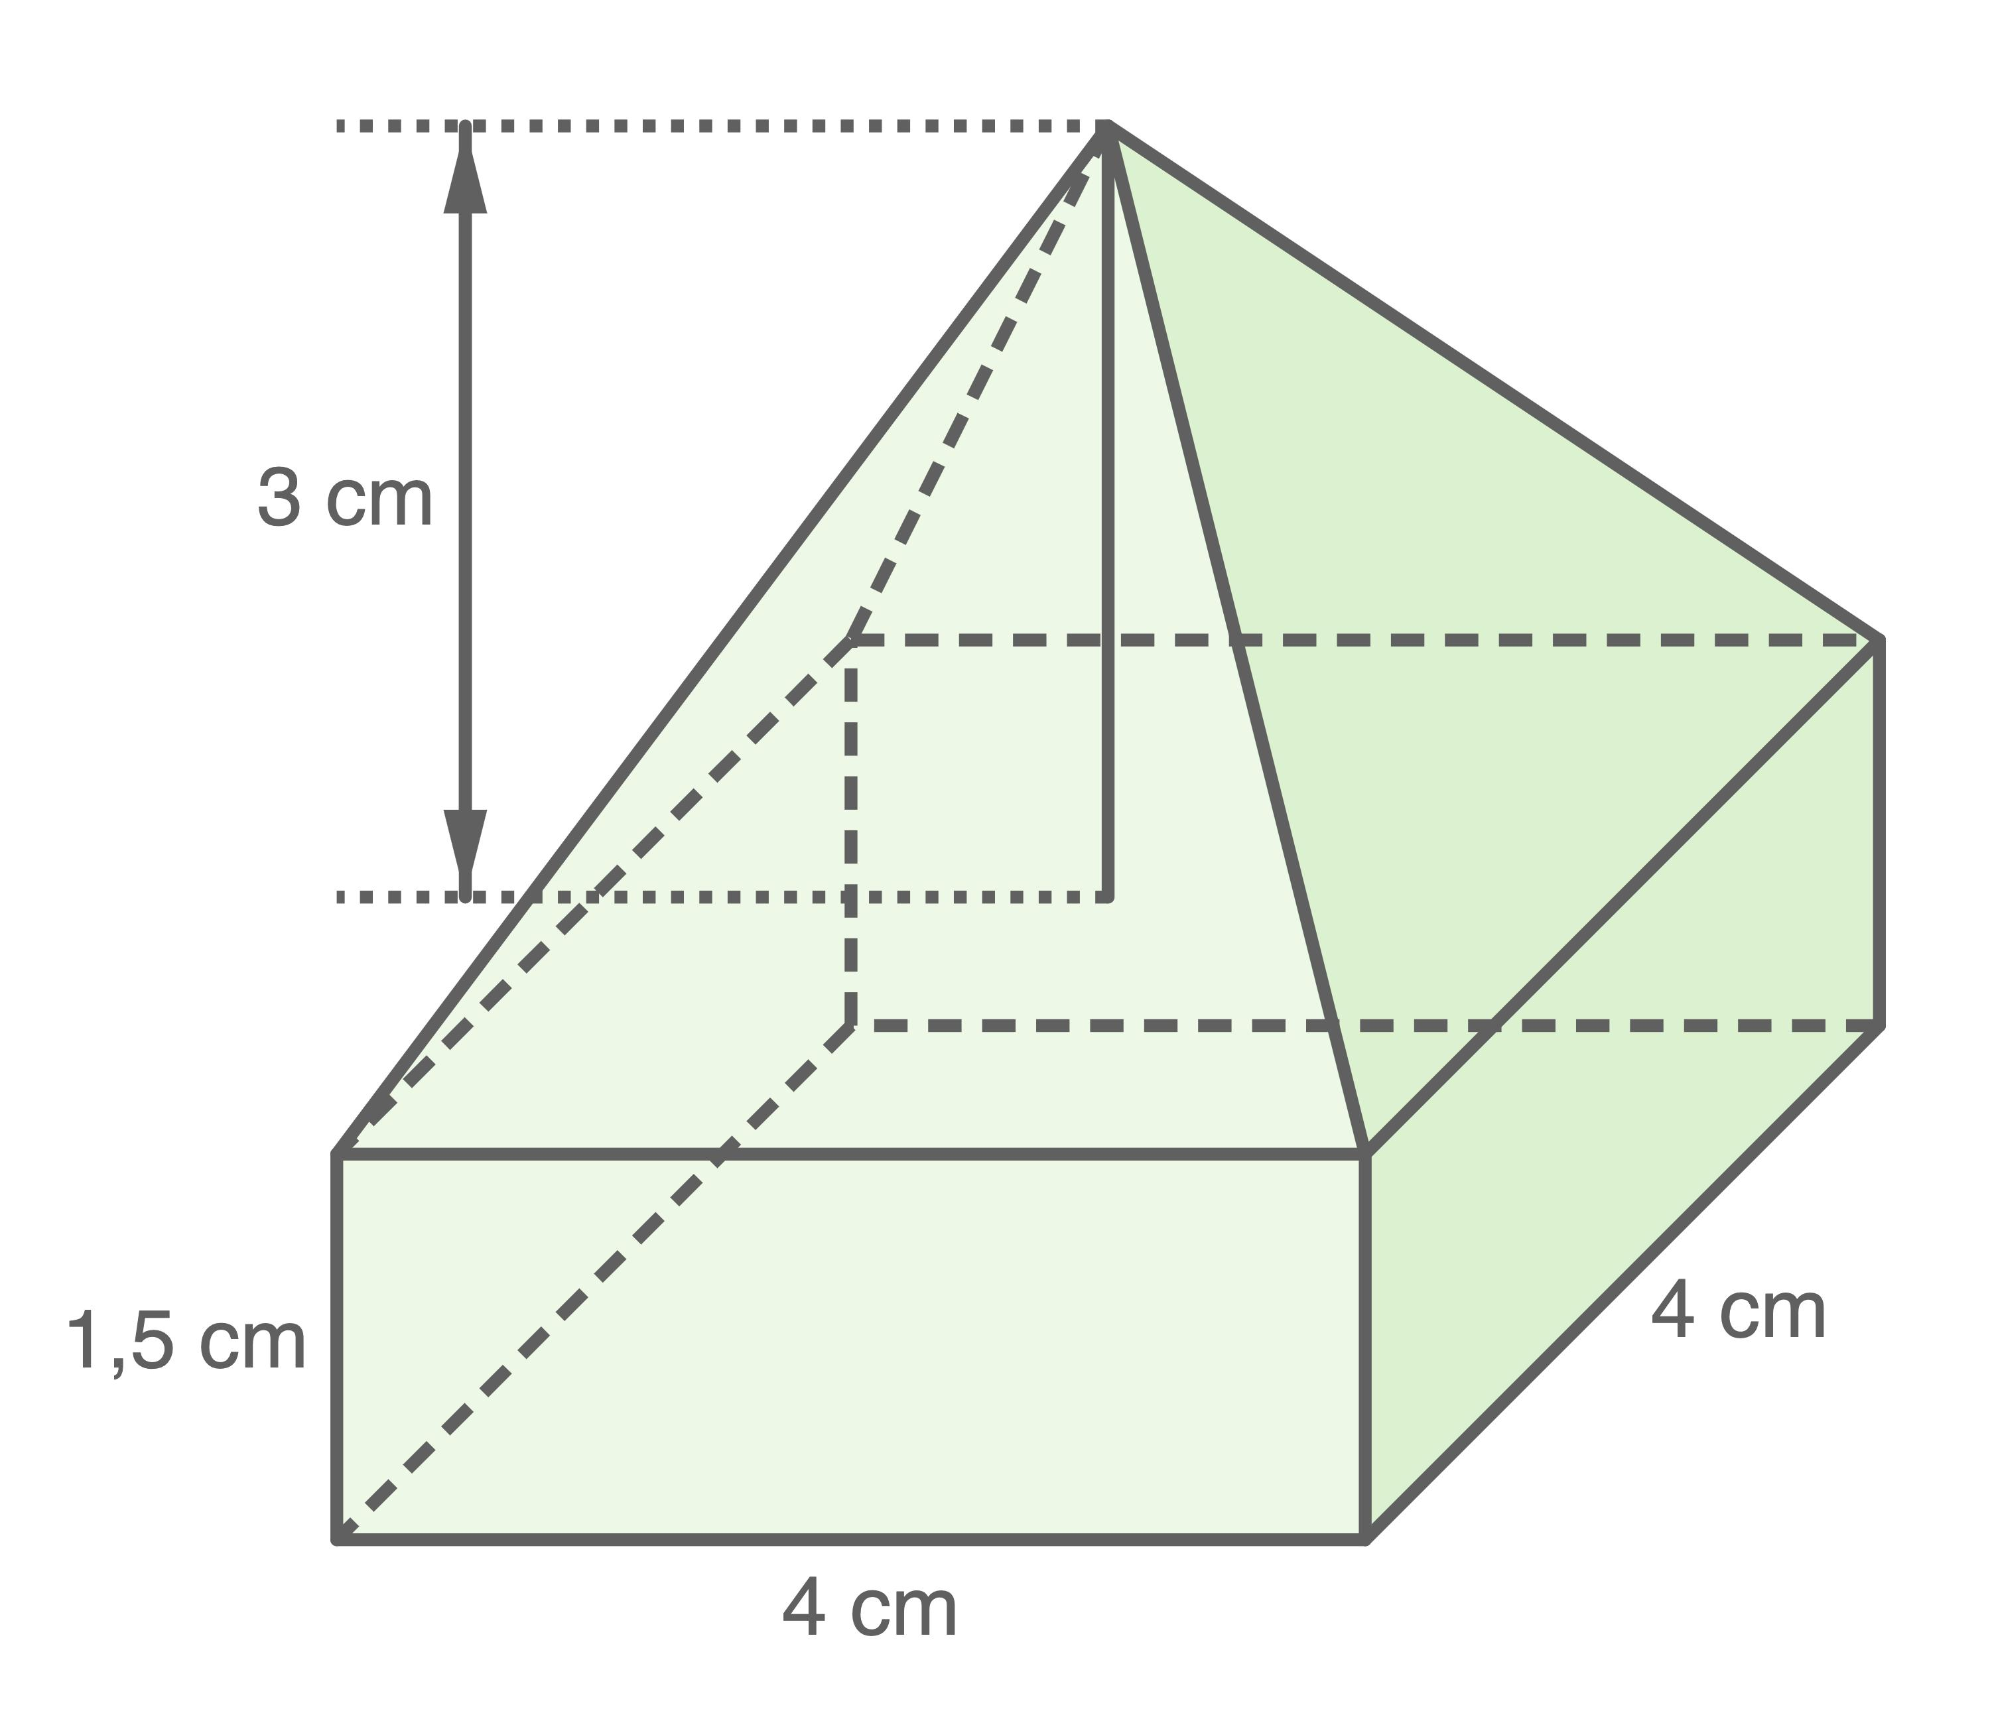
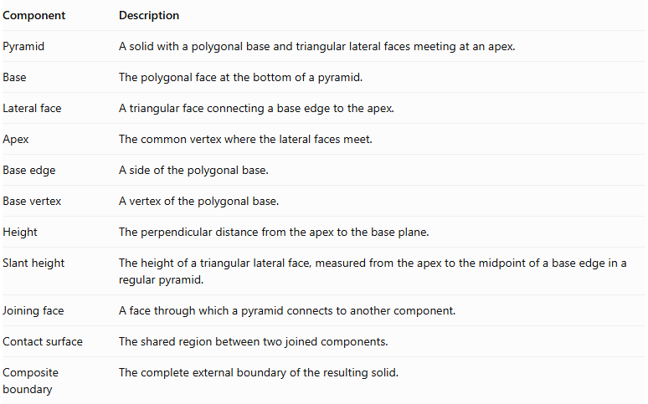
Component | Description
Pyramid | A solid with a polygonal base and triangular lateral faces meeting at an apex.
Base | The polygonal face at the bottom of a pyramid.
Lateral face | A triangular face connecting a base edge to the apex.
Apex | The common vertex where the lateral faces meet.
Base edge | A side of the polygonal base.
Base vertex | A vertex of the polygonal base.
Height | The perpendicular distance from the apex to the base plane.
Slant height | The height of a triangular lateral face, measured from the apex to the midpoint of a base edge in a regular pyramid.
Joining face | A face through which a pyramid connects to another component.
Contact surface | The shared region between two joined components.
Composite boundary | The complete external boundary of the resulting solid.

Types of Pyramid-Based Composite Solids

Pyramid-Based Composite Solids Formed by Joining Pyramids
# Source: AI Source: Provided by: [Data Path: Persons Table -> ID Column: 1, Name_En Column: Motasem Essam] -> From: [ChatGPT] on [7/25/2026]
These solids are created by connecting two or more pyramids.
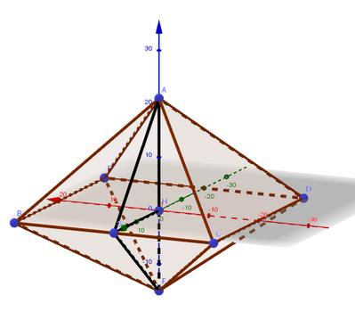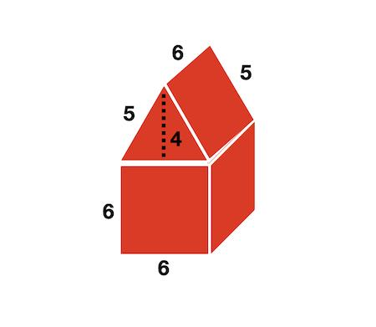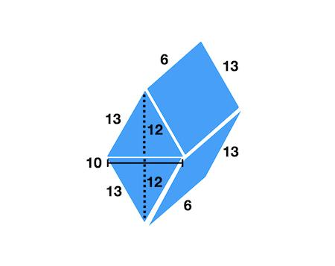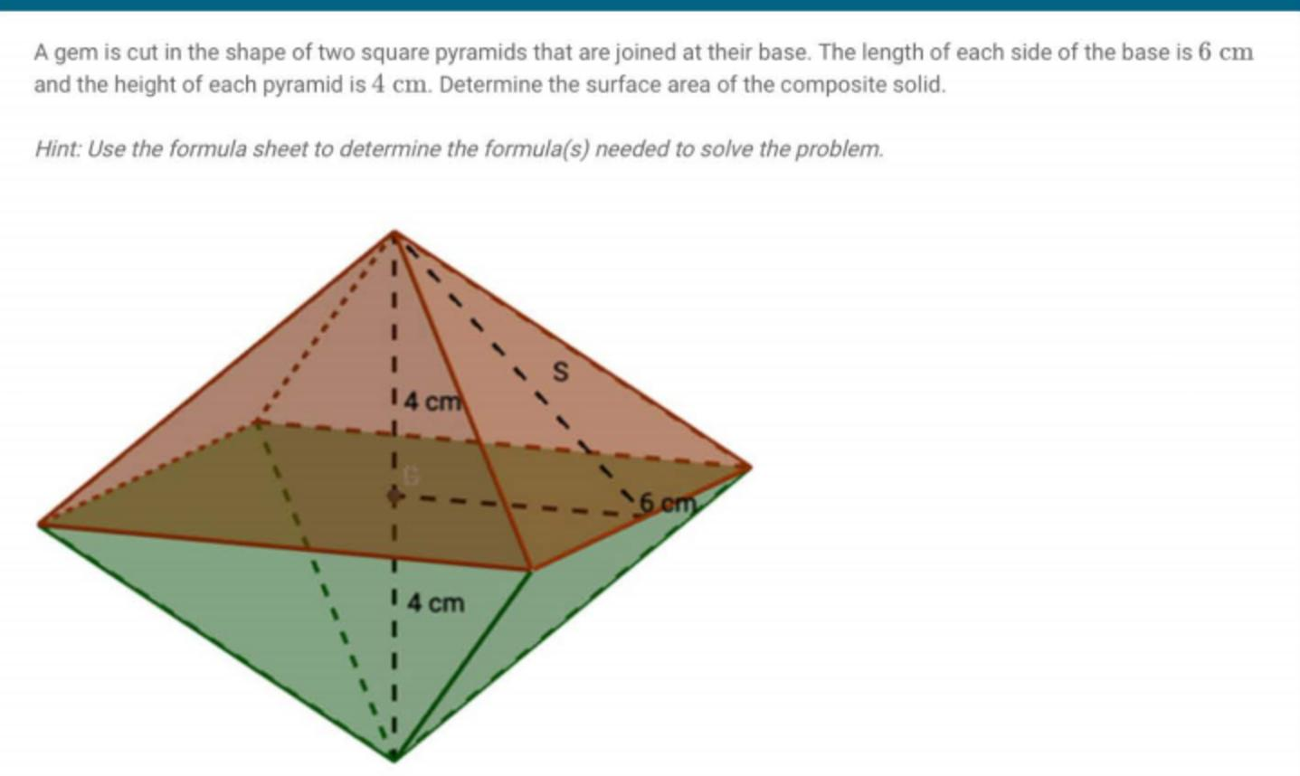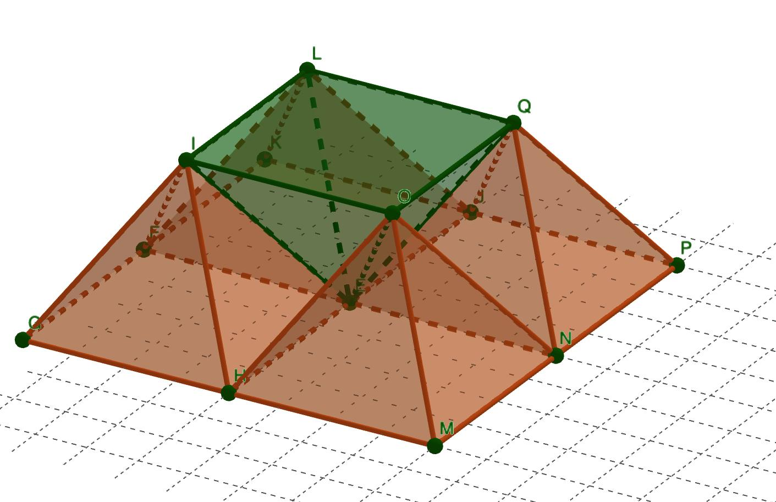
Examples:
- Two square pyramids joined base-to-base.
- Two pyramids joined through matching triangular lateral faces.
- Multiple pyramids connected through their polygonal bases.

Pyramid-on-Prism Composite Solids
# Source: AI Source: Provided by: [Data Path: Persons Table -> ID Column: 1, Name_En Column: Motasem Essam] -> From: [ChatGPT] on [7/25/2026]
These solids are formed by attaching a pyramid to a prism, usually through a matching polygonal base.
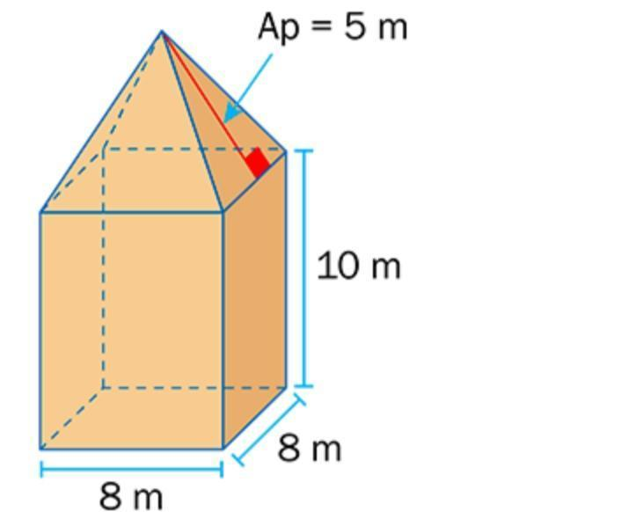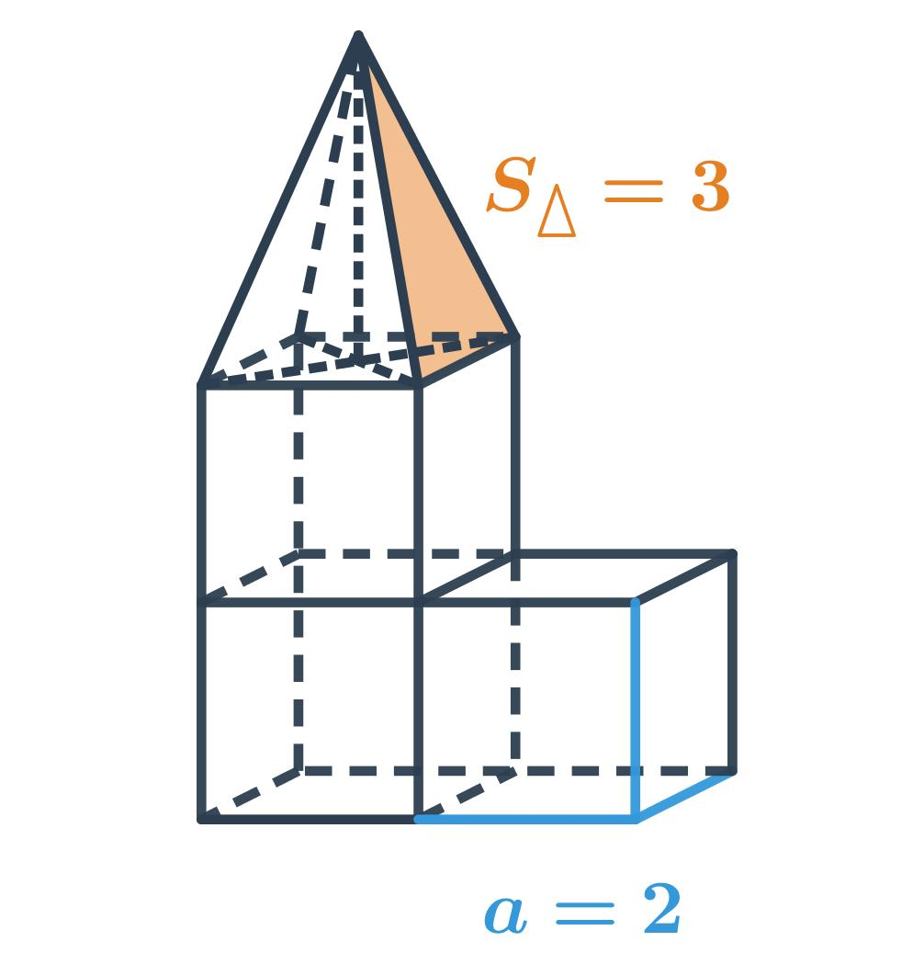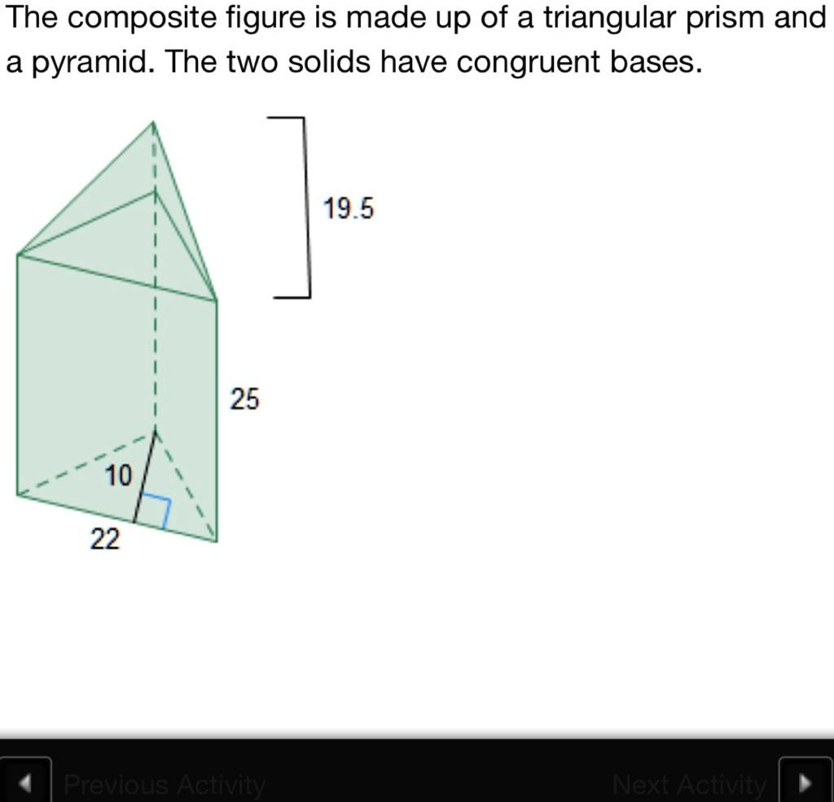
Examples:
- Square pyramid on a cube.
- Square pyramid on a rectangular prism.
- Triangular pyramid on a triangular prism.
- Pentagonal pyramid on a pentagonal prism.

Pyramid-Based Composite Solids with Multiple Pyramids
# Source: AI Source: Provided by: [Data Path: Persons Table -> ID Column: 1, Name_En Column: Motasem Essam] -> From: [ChatGPT] on [7/25/2026]
These solids contain several pyramids connected to one or more central components.
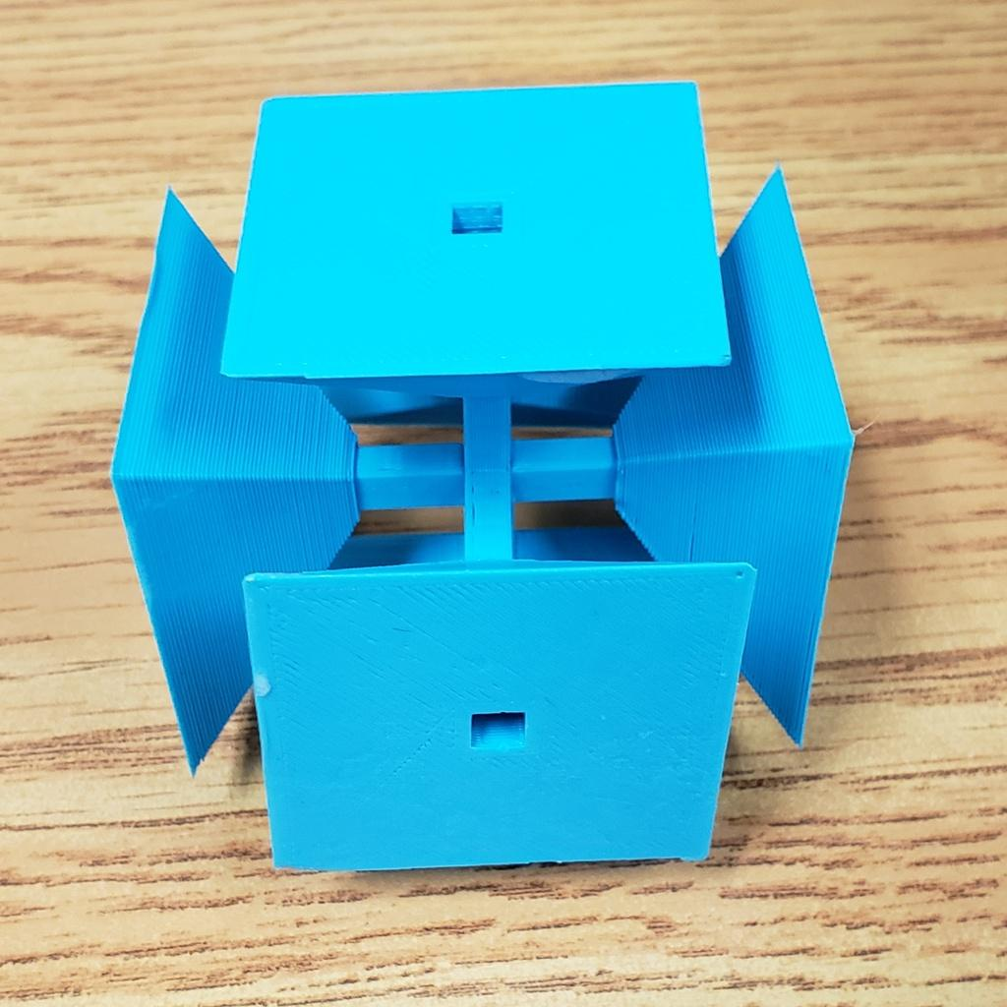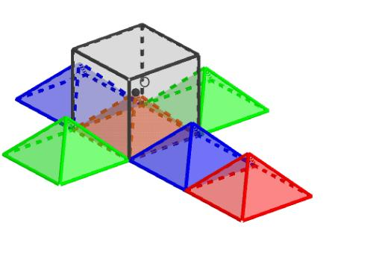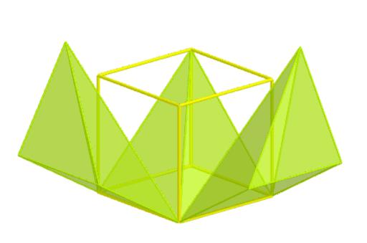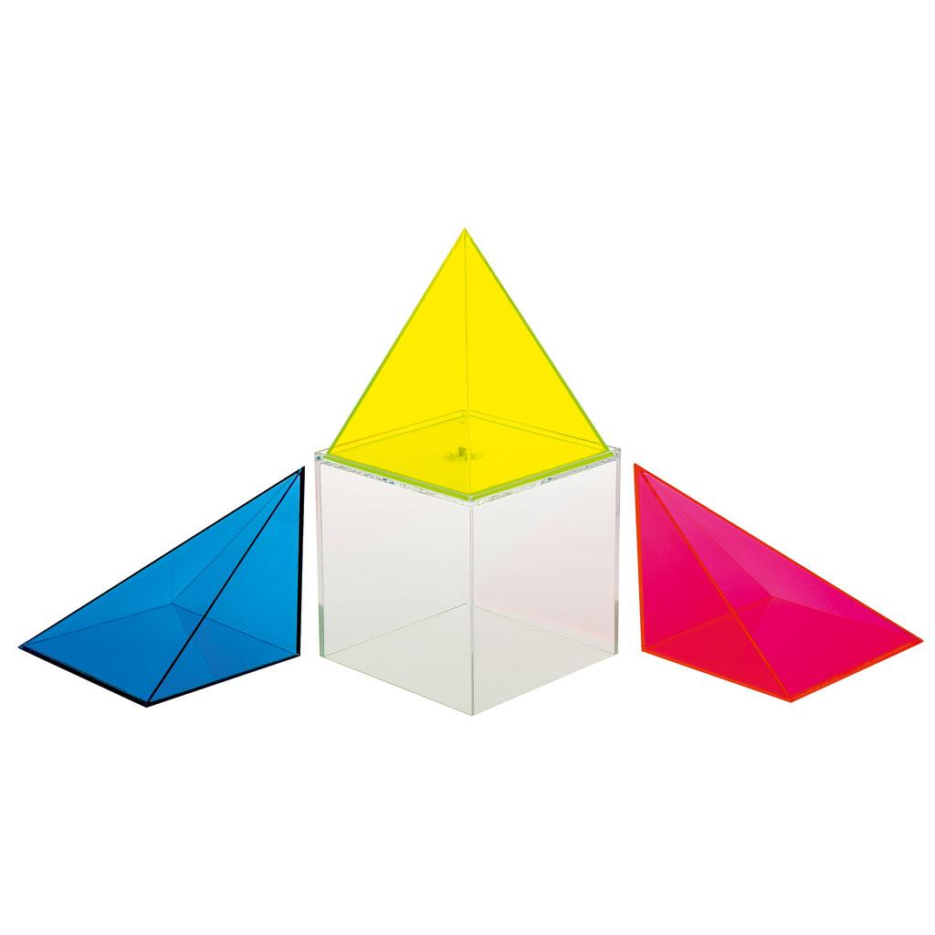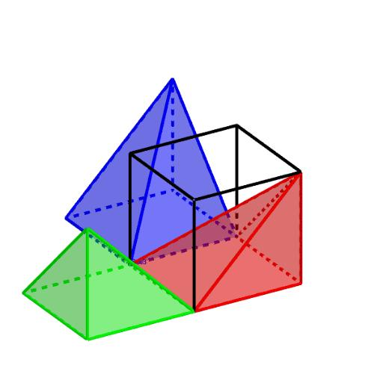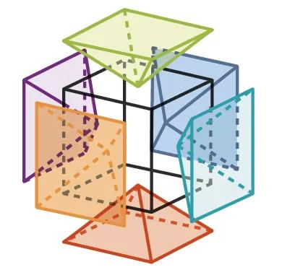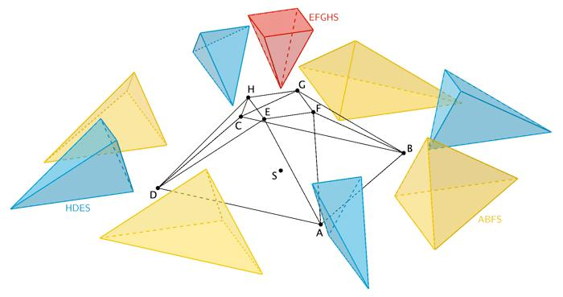
Examples:
- Four pyramids arranged around a central prism.
- Multiple pyramids attached to different faces of a cube.
- Repeated pyramids arranged symmetrically around a central axis.

Pyramid-and-Cylinder Composite Solids
# Source: AI Source: Provided by: [Data Path: Persons Table -> ID Column: 1, Name_En Column: Motasem Essam] -> From: [ChatGPT] on [7/25/2026]
These solids combine one or more pyramids with cylindrical components.
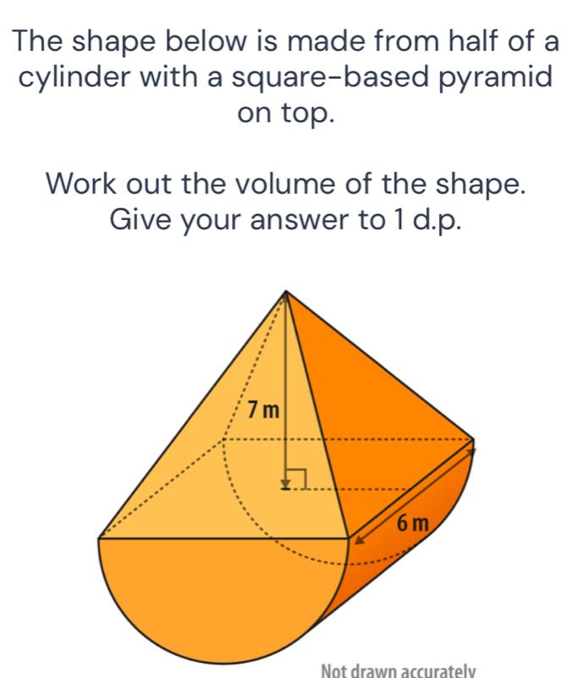
Examples:
- A pyramid attached to a cylinder through a matching contact region.
- A cylinder supporting a pyramid-shaped upper section.
- Multiple pyramids arranged around a cylindrical central component.
Note: A polygonal pyramid and a circular cylinder cannot share an entire base face because their base shapes differ. Such combinations require a smaller matching contact region or an intermediate component.

Mixed Pyramid-Based Composite Solids
# Source: AI Source: Provided by: [Data Path: Persons Table -> ID Column: 1, Name_En Column: Motasem Essam] -> From: [ChatGPT] on [7/25/2026]
These solids combine pyramids with different types of geometric solids, such as prisms, cylinders, cones, or other polyhedra.
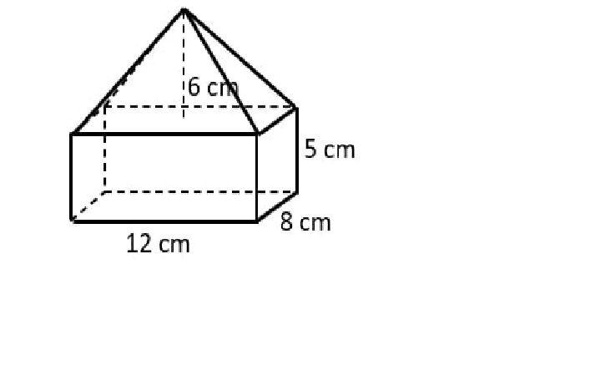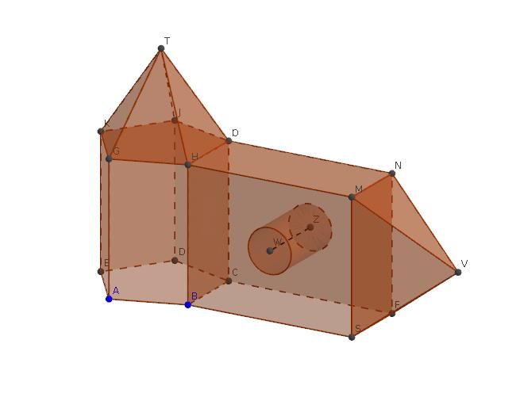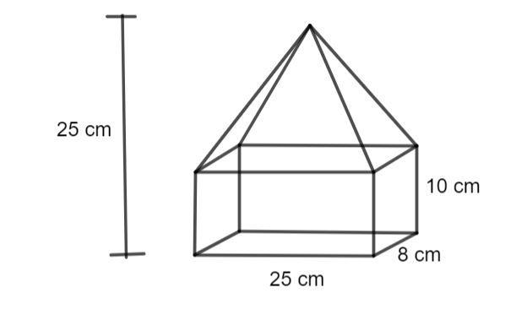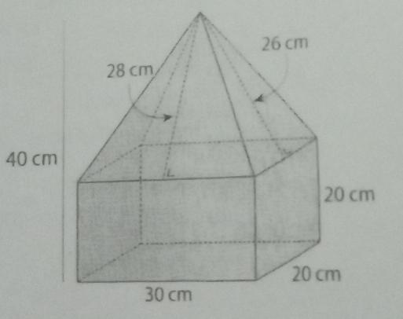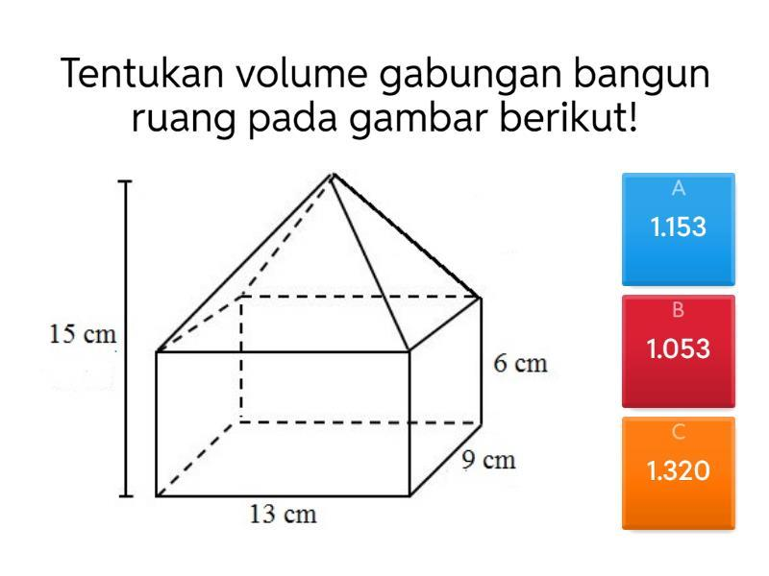
Examples:
- Pyramid + rectangular prism + cylinder.
- Pyramid + cone + prism.
- Multiple pyramids combined with different polyhedra.

Classification by Joining Arrangement
# Source: AI Source: Provided by: [Data Path: Persons Table -> ID Column: 1, Name_En Column: Motasem Essam] -> From: [ChatGPT] on [7/25/2026]
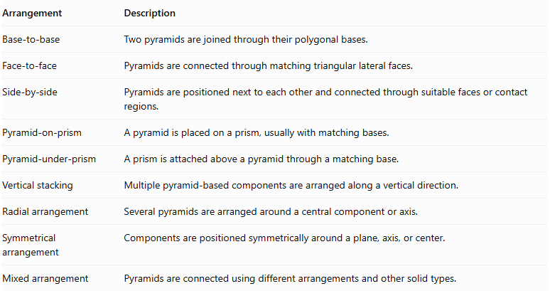
Arrangement | Description
Base-to-base | Two pyramids are joined through their polygonal bases.
Face-to-face | Pyramids are connected through matching triangular lateral faces.
Side-by-side | Pyramids are positioned next to each other and connected through suitable faces or contact regions.
Pyramid-on-prism | A pyramid is placed on a prism, usually with matching bases.
Pyramid-under-prism | A prism is attached above a pyramid through a matching base.
Vertical stacking | Multiple pyramid-based components are arranged along a vertical direction.
Radial arrangement | Several pyramids are arranged around a central component or axis.
Symmetrical arrangement | Components are positioned symmetrically around a plane, axis, or center.
Mixed arrangement | Pyramids are connected using different arrangements and other solid types.

Classification by Pyramid Dimensions
# Source: AI Source: Provided by: [Data Path: Persons Table -> ID Column: 1, Name_En Column: Motasem Essam] -> From: [ChatGPT] on [7/25/2026]
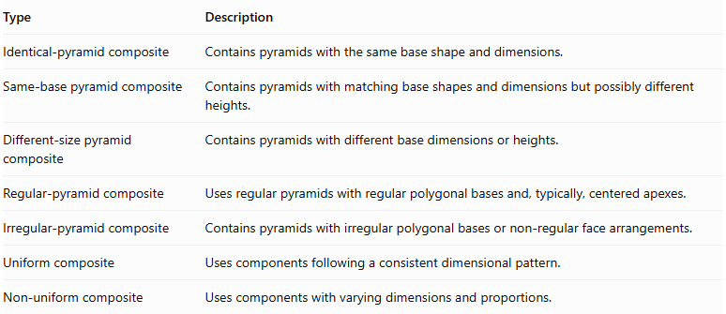
Type | Description
Identical-pyramid composite | Contains pyramids with the same base shape and dimensions.
Same-base pyramid composite | Contains pyramids with matching base shapes and dimensions but possibly different heights.
Different-size pyramid composite | Contains pyramids with different base dimensions or heights.
Regular-pyramid composite | Uses regular pyramids with regular polygonal bases and, typically, centered apexes.
Irregular-pyramid composite | Contains pyramids with irregular polygonal bases or non-regular face arrangements.
Uniform composite | Uses components following a consistent dimensional pattern.
Non-uniform composite | Uses components with varying dimensions and proportions.

Mathematical Properties and Formulas

Volume of a Pyramid-Based Composite Solid
# Source: AI Source: Provided by: [Data Path: Persons Table -> ID Column: 1, Name_En Column: Motasem Essam] -> From: [ChatGPT] on [7/25/2026]
The total volume is the sum of the volumes of its component solids when their interiors do not overlap.
$$V_{total}=V_{1}+V_{2}+⋯+V_{n}$$
The volume of a pyramid is:
$$\boxed{V=\frac{1}{3}Bh}$$
Where:
- $B$ = area of the polygonal base.
- $h$ = perpendicular height of the pyramid.
For a square pyramid:
$$V=\frac{1}{3}s^{2}h$$
For a rectangular pyramid:
$$V=\frac{1}{3}lwh$$
For a triangular pyramid:
$$V=\frac{1}{3}Bh$$
For a composite solid containing pyramids and other solids:
$$V_{total}=\sum{V_{pyramids}}+\sum{V_{other components}}$$
If components overlap in volume, the overlapping region must be subtracted to avoid double-counting.

Surface Area of a Pyramid-Based Composite Solid
# Source: AI Source: Provided by: [Data Path: Persons Table -> ID Column: 1, Name_En Column: Motasem Essam] -> From: [ChatGPT] on [7/25/2026]
The external surface area is the sum of the exposed surfaces of all components. Surfaces hidden inside the composite solid are not included.
For a regular pyramid:
$$SA=B+\frac{1}{2}Pl$$
Where:
- $B$ = base area.
- $P$ = base perimeter.
- $l$ = slant height.
For a composite solid formed by joining two components through matching flat faces:
$${SA}_{total}={SA}_{1}+{SA}_{2}-2A_{contact}$$
Where $A_{contact}$ is the area of the shared joining face.
For multiple joining faces:
$${SA}_{total}=\sum{{SA}_{i}}-2\sum{A_{contact}}$$
This simple formula applies when the joining interfaces are fully shared planar faces. More complicated intersections require calculating the actual exposed boundary.

Slant Height of a Regular Square Pyramid
# Source: AI Source: Provided by: [Data Path: Persons Table -> ID Column: 1, Name_En Column: Motasem Essam] -> From: [ChatGPT] on [7/25/2026]
For a regular square pyramid:
$$l=\sqrt{h^{2}+(\frac{s}{2})^{2}}$$
Where:
- $l$ = slant height.
- $h$ = perpendicular height.
- $s$ = side length of the square base.

Worked Examples

Example 1: Square Pyramid Joined to a Cube
# Source: AI Source: Provided by: [Data Path: Persons Table -> ID Column: 1, Name_En Column: Motasem Essam] -> From: [ChatGPT] on [7/25/2026]
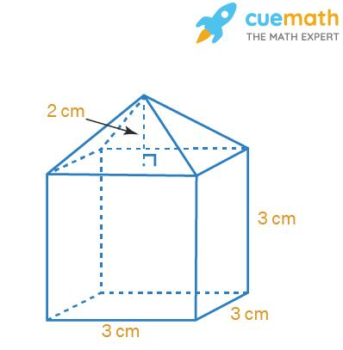
Given:
- Cube side length = $6 cm$.
- Square pyramid base side length = $6 cm$.
- Pyramid height = $4 cm$.
Step 1: Calculate the cube volume.
$$V_{cube}=6^{3}=216{ cm}^{3}$$
Step 2: Calculate the pyramid volume.
$$V_{pyramid}=\frac{1}{3}(6^{2})(4)$$
$$V_{pyramid}=48{ cm}^{3}$$
Step 3: Calculate the total volume.
$$V_{total}=216+48$$
$$\boxed{V_{total}=264{ cm}^{3}}$$
Step 4: Calculate the pyramid slant height.
$$l=\sqrt{4^{2}+3^{2}}=\sqrt{25}=5 cm$$
Step 5: Calculate the external surface area.
The cube's top face is hidden by the pyramid, so only five cube faces are exposed:
$${SA}_{cube exposed}=5(6^{2})=180$$
The pyramid's four triangular lateral faces are exposed:
$${SA}_{pyramid lateral}=4(\frac{1}{2}×6×5)=60$$
$${SA}_{total}=180+60$$
$$\boxed{{SA}_{total}=240{ cm}^{2}}$$
<badge color="success">Final result</badge>
- Total Volume = $264{ cm}^{3}$
- External Surface Area = $240{ cm}^{2}$

Example 2: Two Square Pyramids Joined Base-to-Base
# Source: AI Source: Provided by: [Data Path: Persons Table -> ID Column: 1, Name_En Column: Motasem Essam] -> From: [ChatGPT] on [7/25/2026]
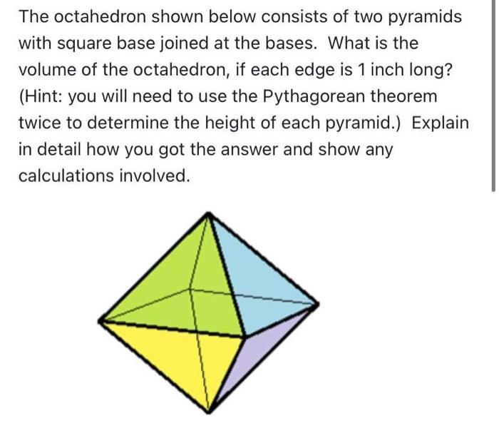
Given:
- Both square bases have side length = $6 cm$.
- First pyramid height = $4 cm$.
- Second pyramid height = $3 cm$.
Step 1: Calculate the first pyramid volume.
$$V_{1}=\frac{1}{3}(6^{2})(4)=48{ cm}^{3}$$
Step 2: Calculate the second pyramid volume.
$$V_{2}=\frac{1}{3}(6^{2})(3)=36{ cm}^{3}$$
Step 3: Calculate the total volume.
$$V_{total}=48+36$$
$$\boxed{V_{total}=84{ cm}^{3}}$$
Step 4: Calculate the slant heights.
First pyramid:
$$l_{1}=\sqrt{4^{2}+3^{2}}=5 cm$$
Second pyramid:
$$l_{2}=\sqrt{3^{2}+3^{2}}=3\sqrt{2} cm$$
Step 5: Calculate the external surface area.
The two square bases are hidden at the joining interface. Only the eight triangular lateral faces are exposed.
$${SA}_{1}=4(\frac{1}{2}×6×5)=60$$
$${SA}_{2}=4(\frac{1}{2}×6×3\sqrt{2})=36\sqrt{2}$$
$${SA}_{total}=60+36\sqrt{2}$$
$$\boxed{{SA}_{total}≈110.91{ cm}^{2}}$$
<badge color="success">Final result</badge>
- Total Volume = $84{ cm}^{3}$
- External Surface Area ≈ $110.91{ cm}^{2}$

Important Characteristics
# Source: AI Source: Provided by: [Data Path: Persons Table -> ID Column: 1, Name_En Column: Motasem Essam] -> From: [ChatGPT] on [7/25/2026]
- Multiple Components: A pyramid-based composite solid contains two or more geometric components.
- Polygonal Bases: Pyramids have polygonal bases, such as triangular, square, rectangular, pentagonal, and hexagonal bases.
- Common Apex: Each pyramid has lateral triangular faces that meet at a single apex.
- Different Orientations: Pyramids can be positioned upright, inverted, tilted, or in other orientations.
- Shared Interfaces: Components may share complete faces or smaller contact regions.
- Volume Addition: Component volumes can be added when their interiors do not overlap.
- External Surface Area: Only exposed surfaces contribute to the total external surface area.
- Variable Geometry: The resulting solid can have different heights, widths, base shapes, and degrees of symmetry.
- Mixed Components: Pyramids can be combined with prisms, cylinders, cones, and other geometric solids.

Comparison with Other Types of Composite Solids
# Source: AI Source: Provided by: [Data Path: Persons Table -> ID Column: 1, Name_En Column: Motasem Essam] -> From: [ChatGPT] on [7/25/2026]
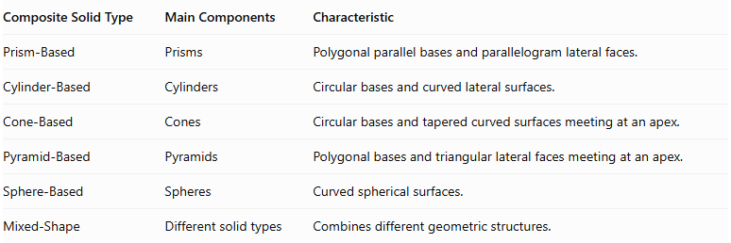
Composite Solid Type | Main Components | Characteristic
Prism-Based | Prisms | Polygonal parallel bases and parallelogram lateral faces.
Cylinder-Based | Cylinders | Circular bases and curved lateral surfaces.
Cone-Based | Cones | Circular bases and tapered curved surfaces meeting at an apex.
Pyramid-Based | Pyramids | Polygonal bases and triangular lateral faces meeting at an apex.
Sphere-Based | Spheres | Curved spherical surfaces.
Mixed-Shape | Different solid types | Combines different geometric structures.

Applications
# Source: AI Source: Provided by: [Data Path: Persons Table -> ID Column: 1, Name_En Column: Motasem Essam] -> From: [ChatGPT] on [7/25/2026]
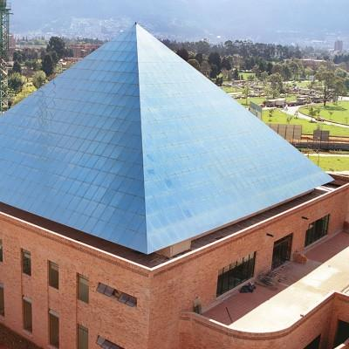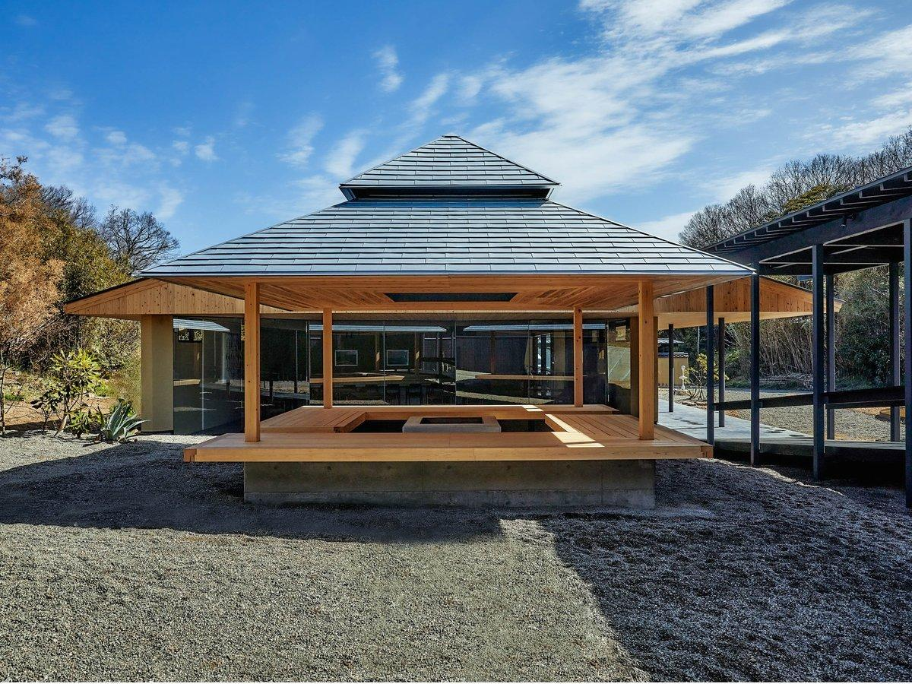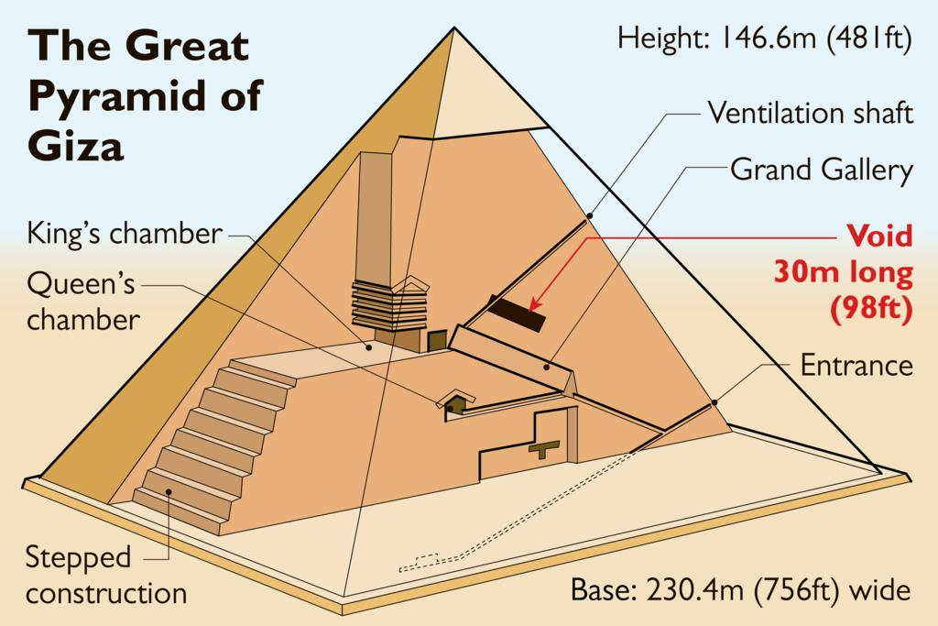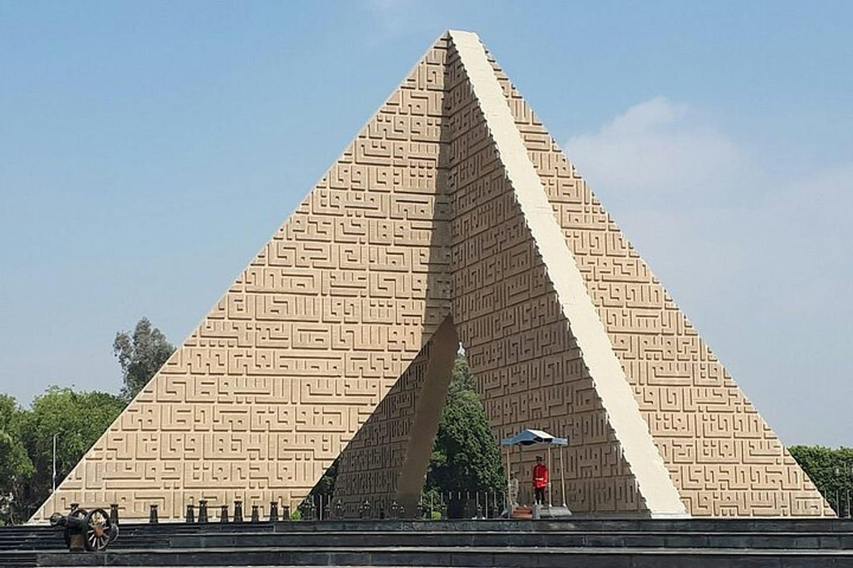
Pyramid-based composite solids appear in several fields:
- Architecture: Pyramid roofs, decorative building tops, and architectural structures.
- Monuments: Pyramid-shaped monuments and multi-level memorial structures.
- Engineering: Structural components and support systems with pyramid-like geometry.
- Product Design: Decorative objects, display structures, and packaging.
- Mathematical Models: Teaching volume, surface area, spatial relationships, and geometric decomposition.
- Computer Graphics: Modeling complex three-dimensional objects using joined polygonal components.

Key Points
# Source: AI Source: Provided by: [Data Path: Persons Table -> ID Column: 1, Name_En Column: Motasem Essam] -> From: [ChatGPT] on [7/25/2026]
- Pyramid-based composite solids are formed by joining two or more pyramids or combining pyramids with other geometric solids.
- Their components may have different base shapes, heights, and orientations.
- Common arrangements include base-to-base, face-to-face, pyramid-on-prism, radial, and symmetrical arrangements.
- The volume of a pyramid is:
$$V=\frac{1}{3}Bh$$
- The volume of a composite solid is the sum of its component volumes when there is no overlapping volume.
- External surface area includes only exposed surfaces.
- Shared joining faces must be excluded from the external surface area.
- The perpendicular height must be used when calculating pyramid volume, not the slant height.

Conclusion
# Source: AI Source: Provided by: [Data Path: Persons Table -> ID Column: 1, Name_En Column: Motasem Essam] -> From: [ChatGPT] on [7/25/2026]
Pyramid-Based Composite Solids are an important category of composite solids formed by addition. They are created by joining multiple pyramids or combining pyramids with other geometric solids.
Their geometric structures can vary considerably depending on the shapes, dimensions, orientations, and joining arrangements of their components. Understanding their composition makes it possible to calculate their total volume and external surface area and to analyze more complex three-dimensional structures.

